A Proposal for a School-Wide Innovation & Formation Framework/Institute

Elevator Pitch:
The purpose of the ‘institute’ is to form students and teachers as image-bearers of God not by chasing technology trends, but by building something that won't change: the why underneath all of it. We exist to equip teachers and students to think creatively, use emerging technology with discernment, and design learning that is innovative, purposeful, and alive. Tools will evolve. The mission never will.

The question this proposal is asking: What if our school had a coordinated, mission-rooted framework to develop teachers and students as innovators, makers, and ambassadors for Christ across every division, every campus?

THE GAP | THE OPPORTUNITY | WHAT WE ARE PROPOSING
Good things are already happening in classrooms across our school, creative projects, technology integration, student-led learning. But they are isolated. Unconnected. Without a shared language or coordinating purpose. When innovation is left to individual teachers, it lives and dies with those individuals and never becomes a culture. | Christian schools are navigating AI, shifting workforce expectations, and students who need more than content, they need formation. We have a moment to lead not by chasing trends, but by anchoring innovation to a clear theological identity. | A school-wide institute that coordinates:  - Student innovation programming (PK-12)  - Teacher development and cohort leadership  - AI/technology literacy as a formation challenge  - Signature showcases and real-world application  - A shared mission language across all divisions  Built on existing staff. Launched in phases. Grounded in mission.

This is not a new department. It is a designation layer on top of existing staff, a coordinating framework, not a new budget line. Leadership roles are assigned to current faculty. Programs build on what is already working. The goal is coherence, not addition.
Why now? AI is already in our classrooms with or without a policy. Students are using it. Teachers are asking for guidance. The choice is not whether to engage it. The choice is whether we engage it intentionally, as a school, rooted in who we are.

What we are asking for: Approval to develop a full framework including name, structure, leadership roles, and phased implementation plan.

NAMING OUR INSTITUTE

Why the Name We Choose Matters
A name is the first thing people encounter before they walk through a door, attend an orientation, or read a brochure. For an institute within a Christian K-12 school, a name carries extraordinary weight when it is theology made visible. Names like Innovation Hub or Creator's Lab borrow identity from Silicon Valley. Names like STEM Center borrow identity from methodology. Neither answers the most important question a Christian school must answer first: Who are we, and why do we exist?

What are students? Image-bearers of God
Purpose of education? Formation as ambassadors for Christ
What will change? Tools, methods, and platforms
What will never change? The why underneath all of it

Questions:
- Does it root us or drift us? Does the name anchor us to our Christian identity, or could it belong to any school or company?
- Does it describe who or what? The best names reflect who students are being formed to be, identity over activity.
- Does it age? Names tied to trends expire. Names tied to enduring theological conviction do not.
- Does it open a conversation or close one? A name that prompts the question "what does that mean?" is often stronger because the answer is your mission.

The goal is not novelty. The goal is clarity about identity. We want a name that a teacher can say with conviction, a student can wear with pride, and a parent can hear and sense that something intentional and serious is happening here.

PROPOSAL: The Echo Foundry Institute

The ECHO Foundry is where students are formed into image-bearers who echo God's wisdom and creativity back into the world equipped through hands-on making, collaborative learning, and purposeful service.

ECHO — can work as both a word and an acronym:
- Equipping, Cultivating, Honoring, Overcoming
- But even without the acronym, echo theologically rich: we are made to echo God's image back into the world. Students don't originate they reflect, amplify, and carry forward what they've received. That's formation.

FOUNDRY — where raw material is refined by heat and pressure into something useful and lasting. It signals:
- Making and craft, not just consuming
- Transformation, not just information
- Tools being forged for real work in the world

Together, ECHO Foundry says: we form students who reflect God's image into the world through purposeful making.

Anticipated objections and responses
Objection | Response
"It sounds too industrial" | That's intentional as a foundry forms something durable. We're not a lab or a lounge, we're forging character and capability.
"Will parents/community get it?" | The word foundry is immediately curious and memorable. It invites the question, which opens the conversation about mission.
"Is it too trendy?" | Unlike terms like makerspace or innovation hub, foundry has historical and biblical weight. It won't age.

The Echo Foundry INSTITUTE
A Model for Innovation, Creativity, and Student Formation in a K-12 Education Setting

Meaning: Echo represents ideas, truth, and impact that extend beyond the classroom, while Foundry represents the intentional shaping, refining, and building of teachers and students through creativity, innovation, leadership, and Christ-centered formation.

Mission: The Echo Foundry Institute exists to develop/form teachers and students as image-bearers of God who cultivate wisdom, creativity, and stewardship through hands-on innovation, collaborative learning, and purposeful service that reflects Christ in the world.

Vision: A generation of teachers and students formed as ambassadors for Christ who think creatively, communicate clearly, lead wisely, and serve faithfully, equipped through integrated learning experiences to design solutions, express ideas, and address real-world challenges in ways that reflect God’s wisdom, creativity, and redemptive purpose in the world.

Stability Statement: The Echo Foundry Institute is guided by enduring principles of formation that remain constant across time, culture, and technological change. While tools, methods, and platforms will evolve, the purpose of education, to form students as ambassadors for Christ who create, communicate, lead, and serve with wisdom and integrity, remains unchanged. Emerging technologies are embraced as instruments for learning and expression, not as drivers of identity or purpose.

Support Structure: The Echo Foundry Institute supports:

- student programming
- teacher development
- innovation implementation
- curriculum integration
- showcases
- strategic growth

Echo Foundry Institute Leadership Structure
These Institute roles are designed as leadership designations (not new positions) assigned to existing faculty and staff positions in order to support and advance the mission, implementation, and collaborative initiatives of the Echo Foundry Institute across the school community.
Role | Primary Focus | Key Responsibilities | Reports to
Director of Echo Foundry Institute | K–12- Vision & Strategic Leadership | Oversees the Institute’s mission, long-term growth, partnerships, framework development, school integration, and alignment across all campuses and divisions. | Associate Head of School
Director of Faculty Innovation & Professional Learning | K–12- Teacher Development & Implementation | Leads professional development, faculty coaching, innovation cohorts, implementation systems, instructional support, and collaborative teacher learning across divisions. | Associate Head of School
Campus Director of Innovation & Learning Design (ES) | ES Innovation Programming | Designs and implements PK–5 innovation experiences focused on wonder, creativity, foundational leadership, interdisciplinary learning, and signature showcases. | Director of Faculty Innovation
Campus Director of Innovation & Learning Design (MS) | MS Innovation Programming | Develops middle school pathways emphasizing collaboration, identity formation, exploration of specializations, innovation projects, and applied problem-solving. | Director of Faculty Innovation
Campus Director of Innovation & Learning Design (HS) | HS Innovation & Career Pathways | Oversees advanced innovation pathways, entrepreneurship, media, STEM specialization, internships, portfolio development, leadership experiences, and real-world application. | Director of Faculty Innovation
Foundry Innovation Lead (ES/MS/HS) | Select representatives for every campus | Serves as an innovation leader and campus implementation partner who helps pilot ideas, support faculty and test emerging tools | Campus Director of Innovation & Learning Design

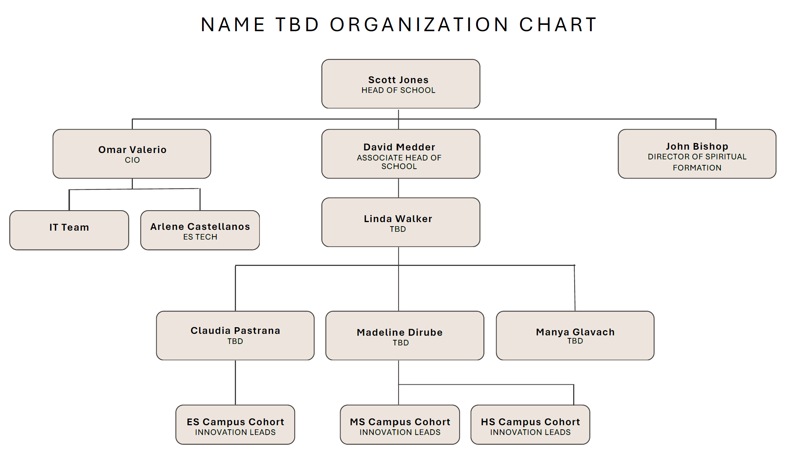
Position Title: Innovation Lead

Reports to: Campus Director of Innovation & Learning Design
Time: One school year

Announcement Blurb
Echo Foundry Innovation Leads are teacher-leaders who help advance a culture of creativity, innovation, and Christ-centered learning across their division. Through collaboration, experimentation, and professional leadership, they support the implementation and growth of the Echo Foundry Framework within our school community.

Position Description
The Echo Foundry Innovation Lead is a collaborative teacher-leader role responsible for advancing a culture of innovation, creativity, and Christ-centered learning within their campus division. Selected for their leadership and forward-thinking approach, Innovation Leads serve as early adopters, strategic collaborators, and implementation partners in the ongoing development of the Echo Foundry Framework.
Through intentional experimentation, professional collaboration, and instructional leadership, Innovation Leads support the design and integration of innovative practices that enhance teaching and learning across the school community.

Primary Responsibilities
Innovation Leads will:
- Pilot and evaluate emerging instructional strategies, tools, and technologies to enhance student learning
- Support the implementation of Echo Foundry initiatives within their assigned campus
- Collaborate with Institute leadership to design, refine, and expand innovative programming
- Serve as a resource and point of contact for faculty, providing guidance and support in adopting new practices/technologies
- Share insights, outcomes, and recommendations with fellow cohort members to inform continuous improvement
- Foster a culture of creativity, collaboration, and future-focused learning among colleagues
- Participate actively in professional learning sessions, planning meetings, and innovation cohorts
- Provide constructive feedback on curriculum design, instructional tools, and systems
- Contribute to the development and execution of signature learning experiences and campus showcases

Desired Qualifications and Characteristics
The ideal candidate demonstrates:
- Initiative and creative problem-solving in instructional design
- Strong collaboration and interpersonal skills
- Openness to innovation, experimentation, and iterative improvement
- A student-centered mindset with a focus on meaningful learning experiences
- The ability to influence and lead peers through example and encouragement
- Adaptability, reflective practice, and a growth-oriented mindset
- A deep commitment to Christ-centered education and student formation

Professional Impact
Echo Foundry Innovation Leads play a critical role in shaping the future of teaching and learning within their division. By modeling innovative practices and supporting their colleagues, they help ensure that the Echo Foundry Framework is implemented with excellence, purpose, and alignment to the school’s mission.

Time Commitment
Innovation Leads are expected to participate in regular planning meetings, professional learning sessions, and cohort collaborations throughout the school year. Additional time may be required for piloting initiatives, supporting colleagues, and contributing to key events such as showcases and program development.

Stipend
A stipend will be provided in recognition of the additional leadership responsibilities and contributions associated with this role, as determined by school leadership.

Project: Artificial Intelligence Literacy

Mission: To equip educators and students to thoughtfully, ethically, and creatively integrate artificial intelligence into teaching and learning through collaboration, innovation, and Christ-centered discernment.

Vision: A school community where emerging technologies enhance creativity, critical thinking, communication, and meaningful learning while students and educators engage with AI wisely, responsibly, and as ambassadors for Christ.

Initiative Focus Areas
The AI Literacy Initiative will focus on:
- Exploring practical classroom applications for AI tools
- Supporting responsible and age-appropriate implementation
- Evaluating instructional impact and effectiveness
- Promoting ethical and transparent AI practices
- Encouraging innovation while maintaining strong instructional foundations
- Navigating emerging technologies with purpose while supporting thoughtful and responsible implementation.

Areas of Exploration
Throughout the school year, Innovation Leads participating in this initiative will engage in:
- Piloting approved AI platforms and instructional workflows
- Exploring ways AI can support planning, differentiation, creativity, and productivity
- Identifying appropriate student use cases and boundaries
- Discussing challenges related to academic integrity and critical thinking
- Sharing practical classroom examples and implementation reflections
- Collaborating on best practices for responsible AI integration
- Helping shape future professional learning opportunities and schoolwide guidance

Quarterly Collaboration Meetings
Innovation Leads connected to the AI Literacy Initiative will participate in quarterly collaboration sessions focused on:
- Sharing implementation experiences
- Evaluating successes and challenges
- Discussing emerging tools and trends
- Reflecting on ethical considerations and instructional impact
- Collaborating on recommendations for future implementation

Guiding Principles
The AI Literacy Initiative is grounded in the belief that technology should serve learning, not replace it and seeks to ensure that AI remains a tool that supports:
- creativity and innovation
- critical thinking and discernment
- responsible leadership
- meaningful student engagement
- Christ-centered learning and formation

